**Feature Crosses**



A **feature cross** is a **synthetic feature** formed by multiplying (crossing) two or more features. Crossing combinations of features can provide predictive abilities beyond what those features can provide individually.

* **Feature crosses** is the name of this approach
* Define templates of the form [A x B]
* Can be complex: [A x B x C x D x E]
* When A and B represent boolean features, such as bins, the resulting crosses can be extremely sparse

## Feature Crosses: Some Examples

* **Housing market price predictor:**

[latitude X num_bedrooms]

* **Tic-Tac-Toe predictor:**

[pos1 x pos2 x ... x pos9]

## Feature Crosses: Why would we do this?

* Linear learners use linear models
* Such learners scale well to massive data e.g., Vowpal Wabbit, sofia-ml
* But without feature crosses, the expressivity of these models would be limited
* Using feature crosses + massive data is one efficient strategy for learning highly complex models
  + Foreshadowing: neural nets provide another

# Feature Crosses: Encoding Nonlinearity

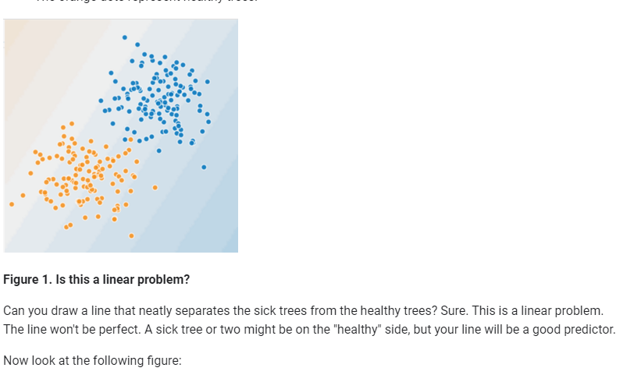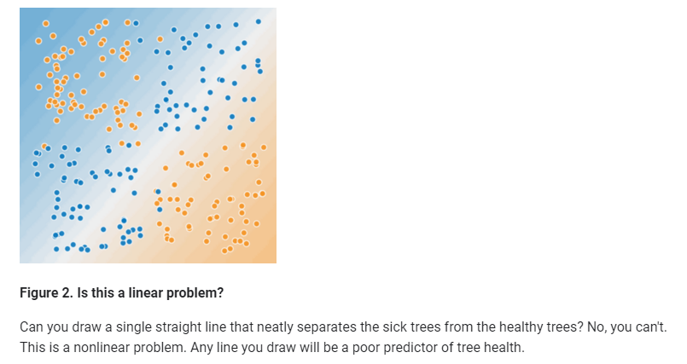

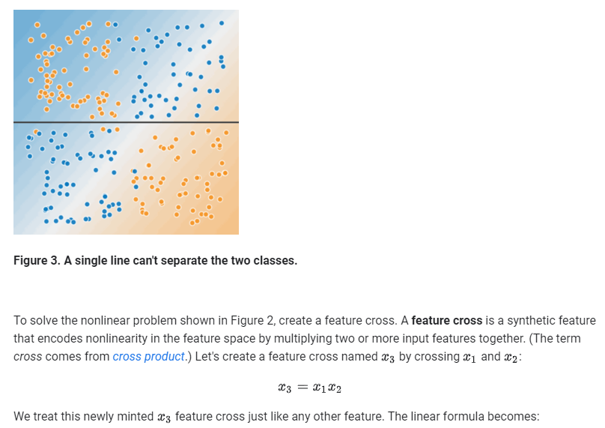We treat this newly minted x3 feature cross just like any other feature. The linear formula becomes:

y=b+w1x1+w2x2+w3x3

A linear algorithm can learn a weight for w3 just as it would for w1 and w2. In other words, although w3 encodes nonlinear information, you don’t need to change how the linear model trains to determine the value of w3.

# Feature Crosses: Crossing One-Hot Vectors

 So far, we've focused on feature-crossing two individual floating-point features. In practice, machine learning models seldom cross continuous features. However, machine learning models do frequently cross one-hot feature vectors. Think of feature crosses of one-hot feature vectors as logical conjunctions. For example, suppose we have two features: country and language. A one-hot encoding of each generates vectors with binary features that can be interpreted as country=USA, country=France or language=English, language=Spanish. Then, if you do a feature cross of these one-hot encodings, you get binary features that can be interpreted as logical conjunctions, such as:

  country:usa AND language:spanish

As another example, suppose you bin latitude and longitude, producing separate one-hot five-element feature vectors. For instance, a given latitude and longitude could be represented as follows:

binned_latitude = [0, 0, 0, 1, 0]

binned_longitude = [0, 1, 0, 0, 0]

Suppose you create a feature cross of these two feature vectors:

binned_latitude X binned_longitude

This feature cross is a 25-element one-hot vector (24 zeroes and 1 one). The single 1 in the cross identifies a particular conjunction of latitude and longitude. Your model can then learn particular associations about that conjunction.

Suppose we bin latitude and longitude much more coarsely, as follows:

binned_latitude(lat) = [

0 < lat <= 10

10 < lat <= 20

20 < lat <= 30

]

binned_longitude(lon) = [

0 < lon <= 15

15 < lon <= 30

]

Creating a feature cross of those coarse bins leads to synthetic feature having the following meanings:

binned_latitude_X_longitude(lat, lon) = [

0 < lat <= 10 AND 0 < lon <= 15

0 < lat <= 10 AND 15 < lon <= 30

10 < lat <= 20 AND 0 < lon <= 15

10 < lat <= 20 AND 15 < lon <= 30

20 < lat <= 30 AND 0 < lon <= 15

20 < lat <= 30 AND 15 < lon <= 30

]

Now suppose our model needs to predict how satisfied dog owners will be with dogs based on two features:

* Behavior type (barking, crying, snuggling, etc.)
* Time of day

If we build a feature cross from both these features:

[behavior type X time of day]

then we'll end up with vastly more predictive ability than either feature on its own. For example, if a dog cries (happily) at 5:00 pm when the owner returns from work will likely be a great positive predictor of owner satisfaction. Crying (miserably, perhaps) at 3:00 am when the owner was sleeping soundly will likely be a strong negative predictor of owner satisfaction.

Linear learners scale well to massive data. Using feature crosses on massive data sets is one efficient strategy for learning highly complex models. [Neural networks](https://developers.google.com/machine-learning/crash-course/introduction-to-neural-networks) provide another strategy.